Technical Documentation

Sorting Names

Author: Siska Limanto

Creation Date: October 19, 2018

Last Updated: October 19, 2018

File Name: Technical Documentation – Sorting Names.docx

Version: 1.0

1. **Title, Subject, Last Updated Date, Reference Number**, **and** **Version** are marked by a Word Bookmark so that they can be easily reproduced in the header and footer of documents. When you change any of these values, be careful not to accidentally delete the bookmark. **You can make bookmarks visible by selecting Tools->Options…View and checking the Bookmarks option in the Show region.**

## Document Control

**Change Record**

3

| Date | Author | Version | Change Reference |
| --- | --- | --- | --- |
|  |  |  |  |
| 19-Oct-18 | Siska Limanto | 1.0 | No previous document |
|  |  |  |  |
|  |  |  |  |
|  |  |  |  |
|  |  |  |  |

**Reviewers**

| Name | Position |
| --- | --- |
|  |  |
| Kreatifitas Sinergisme Teknoindo | Reviewer |
|  |  |
|  |  |
|  |  |

**Repository**

| No. | Location | Reference |
| --- | --- | --- |
|  |  |  |
|  | GitHub |  |
|  |  |  |
|  |  |  |
|  |  |  |

1. The copy numbers referenced above should be written into the **Copy Number** space on the cover of each distributed copy. If the document is not controlled, you can delete this table, the Note To Holders, and the **Copy Number** label from the cover page.

**Note to Holders:**

If you receive an electronic copy of this document and print it out, please write your name on the equivalent of the cover page, for document control purposes.

If you receive a hard copy of this document, please write your name on the front cover, for document control purposes.

## General Information

Below is the general information **only** regarding of this (the latest) change request.

#### Change Request Number

#### Change Request Description

#### Platform & Module Related

#### Complexity

|  |  |  |  |
| --- | --- | --- | --- |
| Backend | High | Medium | Low |

Contents

Document Control 2

General Information 3

Background 5

Case & Requirement 6

Case & Requirement #1 6

Solutions 7

Solution #1 7

Open and Closed Issues for this Deliverable 9

Open Issues 10

Closed Issues 10

1. To update the table of contents, put the cursor anywhere in the table and press [F9]. To change the number of levels displayed, select the menu option Insert‑>Index and Tables, make sure the Table of Contents tab is active, and change the Number of Levels to a new value.

If you use a user-friendly name for this customization as the replacement for <Subject>, the following paragraphs will default nicely.

## Background

Sorting Names project is built for coding assessment purpose to determine Technical Lead Role. This project will be reviewed to see

1. Does the code easy to understand by other engineer
2. Ability to compose quality code that adheres SOLID
3. How to write the test

## Case & Requirement

### Case & Requirement #1

#### Case #1

Reviewer need to see stack of names that have been sorted by their last name

#### Requirement #1

Build a name sorter. Given a set of names, order that set first by last name, then by any given names the person may have. A name must have at least 1 given name and may have up to 3 given names.

*Example Usage*

Given a a file called unsorted-names-list.txt containing the following list of names;

Orson Milka Iddins  
Erna Dorey Battelle  
Flori Chaunce Franzel  
Odetta Sue Kaspar  
Roy Ketti Kopfen  
Madel Bordie Mapplebeck  
Selle Bellison  
Leonerd Adda Mitchell Monaghan  
Debra Micheli  
Hailey Avie Annakin

Executing the program in the following way;

name-sorter ./unsorted-names-list.txt

Should result the sorted names to screen;

Hailey Avie Annakin  
Erna Dorey Battelle  
Selle Bellison  
Flori Chaunce Franzel  
Orson Milka Iddins  
Odetta Sue Kaspar  
Roy Ketti Kopfen  
Madel Bordie Mapplebeck  
Debra Micheli  
Leonerd Adda Mitchell Monaghan

and a file in the working directory called sorted-names-list.txt containing the sorted names.

## Solutions

### Solution #1

This codes have been separated by 3 sections

1. Read file

First, reviewer need to upload the file which contain names on it

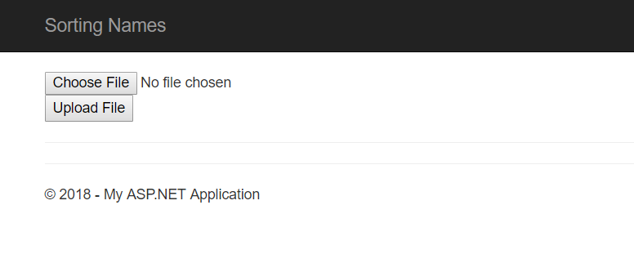

The file will be saved on App_Data (Upload()) then the code will redirect to SortPerson.

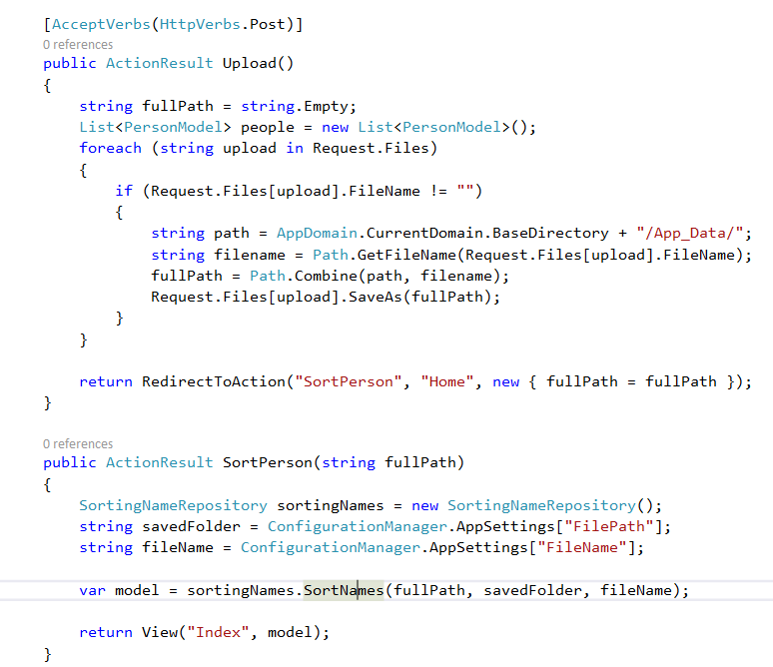

In SortingNameRepository, the file will be read and will be filled to List of PersonModel

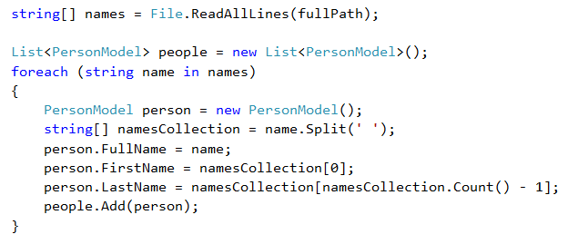

1. Sort names

Then the list will be sorted by last name



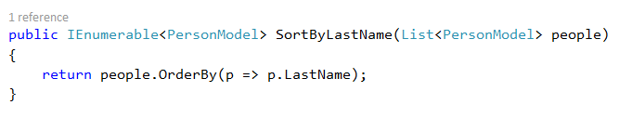

1. Show to screen and saved file

After sort the names, it will be saved to App_Data and show to screen



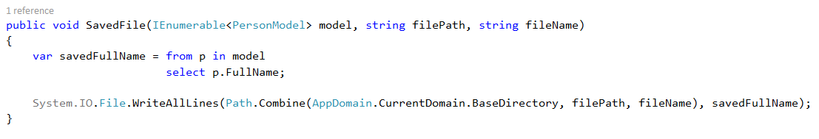

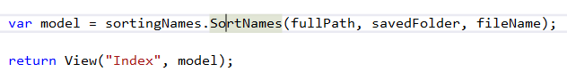

Folder path and file name are set in file config so that engineer can change the path and file name without built the solution



This is the Result

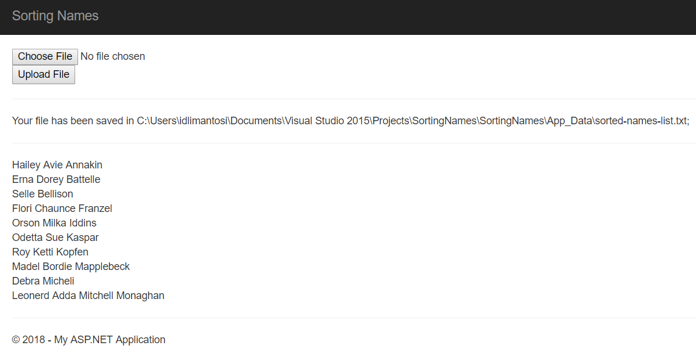

## Open and Closed Issues for this Deliverable

1. Add open issues that you identify while writing or reviewing this document to the open issues section. As you resolve issues, move them to the closed issues section and keep the issue ID the same. Include an explanation of the resolution.  
     
   When this deliverable is complete, any open issues should be transferred to the project- or process-level Risk and Issue Log (PJM.CR.040) and managed using a project level Risk and Issue Form (PJM.CR.040). In addition, the open items should remain in the open issues section of this deliverable, but flagged in the resolution column as being transferred.

### Open Issues

| ID | Issue | Resolution | Responsibility | Target Date | Impact Date |
| --- | --- | --- | --- | --- | --- |
|  |  |  |  |  |  |
|  |  |  |  |  |  |
|  |  |  |  |  |  |
|  |  |  |  |  |  |
|  |  |  |  |  |  |

### Closed Issues

| ID | Issue | Resolution | Responsibility | Target Date | Impact Date |
| --- | --- | --- | --- | --- | --- |
|  |  |  |  |  |  |
|  |  |  |  |  |  |
|  |  |  |  |  |  |
|  |  |  |  |  |  |
|  |  |  |  |  |  |